**ISO Technical Schematic Overview:**

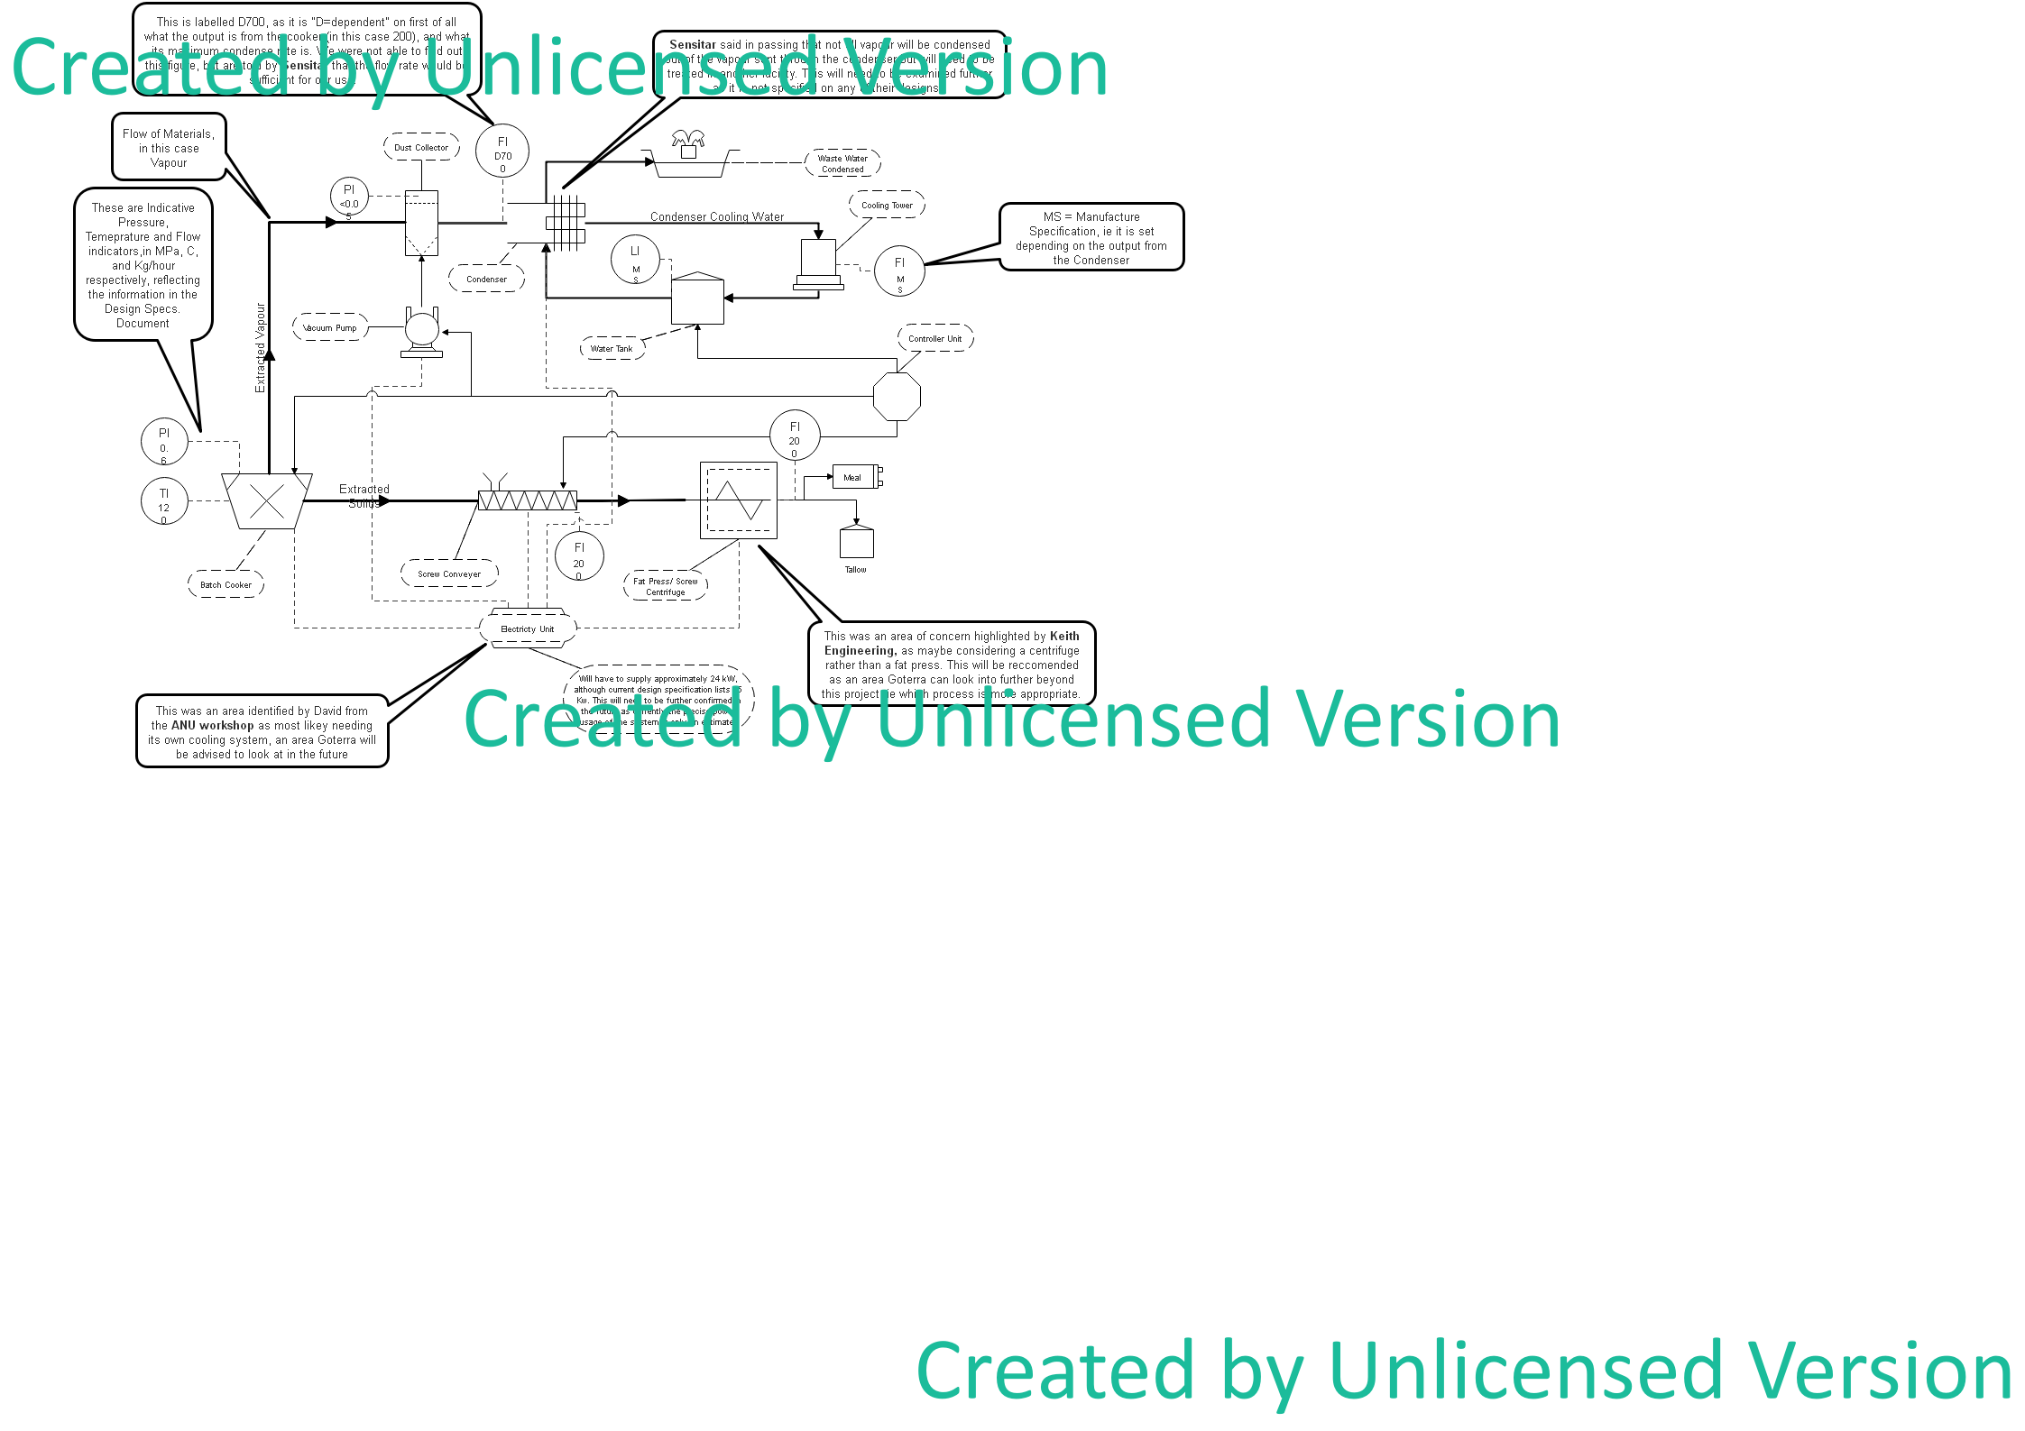

**Description of the Module Process:**

1. Insects are moved into the Batch Cooker post death, their moisture content at this point being 70-75% water, and 20-25% dry matter.
2. I use the term “batch cooker” as it cooks in “batches”, rather than the material moving continuously through. So essentially for the first 2 hours, it is only the continuous cooker working, evaporating the water into the contained chamber. After this the chamber is opened to the rest of the system, the vapour being extracted as the material is then “dried” for 3 hours. This is how Sensitar who we are sourcing the cooker from, explained the process, with the dimensions provided as those in the pdf.
3. Once dry, the material is then moved through the Screw conveyer into the Fat press, where the tallow and meal are separated, moving into storage containers outside of the crates themselves.
4. During the drying process, the vapour travels through the “dust collector”, which essentially removes any impurities or residual particles from the vapour, before it moves into the Condenser.
5. The Condenser then runs cooler, outside water in pipes through the chamber, to condense the much hotter vapour coming in from the dust collector and continuous cooker.
6. The “waste water” (condensed vapour from cooker) then flows out of the system (probably into an outside tank nearby) to be treated separately, and the cooling water that helped in the condensing process, flows into the Cooling Tower and then into the water Storage tank.

**See also:**

* **Design specifications:** <https://github.com/JessYJY/InsectFarming/blob/master/Final%20Document/Design%20Components%20Specification.xlsx>
* **System Architecture:** <https://github.com/JessYJY/InsectFarming/blob/master/Final%20Document/SystemArchitecture.png>
* **Physical Overview Schematic:** <https://github.com/JessYJY/InsectFarming/blob/master/Final%20Document/FinalDesignPhysicalOverview2D.png>
* **Edraw master file of the above drawing:** <https://github.com/JessYJY/InsectFarming/blob/master/Final%20Document/ISO%20Technical%20Schematic.eddx>
* **Preliminary Budget:** <https://github.com/JessYJY/InsectFarming/blob/master/Final%20Document/GoterraBudget.xlsx>

**Areas for future changes/considerations:**

